

**Neha Deshmukh**

Career Objective  
_____________________  
Neha wants to excel and be competitive in the field of teaching while sharing knowledge and skills, which will enable her to excel as a teacher/trainer/lecturer. She wishes to assimilate knowledge and gain insight as to how to constantly be able to improve herself to be able to deliver the best. 

She has worked at Infosys Technology : (From June’04 – Feb’09 ) in Software Project Management Team as  Process and Soft skills Trainer   
  
She has done her (Management Studies) at RSSP’s Institute of Management and Computers Studies (From Jan’09 till Oct’11) as Pune University Approved Assistant Professor   
  
She is currently working with New India School as a High School Teacher.

**5 E Lesson Plan**

1. Name of the School: New India School
2. Name of the Teacher: Mrs. Neha Anuj Deshmukh
3. Date: 30/11/2018
4. Subject: Geography
5. Grade: VIII
6. Topic: Industries
7. Unit: 8
8. State Curriculum Standards: State Board

# Lesson / Unit Planning:

1. Short Description of the Concept: Types of Industries, types of occupations, factors responsible for the development of an industry, factors responsible for the economic development of a country, MIDC, Corporate Social Responsibility, effects of Industrialization on environment etc.
2. Statement of Learning Objectives: To help the students to be able to classify the industries, construct the mind map, value the concept of CSR, evaluate the project of Make in India , visualize the effects of Industrialisation, make some games for making learning interesting, use computer for learning and understanding.
3. Differentiation strategies to meet diverse learner needs: Usage of computer for PowerPoint Presentations, Videos, low tech activities/ technology based activities, conducting group activities etc.
4. Common Learners Misconceptions: The students are unaware that they can become an Entrepreneur and start a new business which can help and support India’s swadeshi movement ‘Make in India’. Also, students don’t know about the importance of Industrialisation.
5. Adaptations/ Accommodations’ for Exceptional Students: Some exceptional talented students can do research projects or collaborative learning, go for a field visit to a nearby factory, plan a low tech activity/ some group activity/ conduct a PowerPoint presentation etc..
6. Precautions/ Safety measures: Students have to be careful during the field visit and listen to the teacher’s instruction. Usage of internet should be under elder’s vigilance.
7. ***Instructional Process:***

|  |  |  |  |
| --- | --- | --- | --- |
| **5E Phases** | **Activities /Events** | **Guiding questions** | **Materials** |
| Engage | Students will:  1) Recall by watching an animated video and discussing the video.  2) Creating a Mind map -  1) Low tech- on paper, WinWord  2) High tech - ‘Popplet’ using internet. | Describe how is the raw material converted into the finished product?  Which raw material is required for which industry?  How does small industry contrast with large industry? | 1)Paper, coloured pens to draw mind map  2)Computer with internet facility |
| Explore | The students will:  1. Research and find out the factors affecting the location of the industry.  2. Demonstrate the understanding by sharing the information in 4 groups.  3. Prepare a “Multiple Choice Questionnaire’ using ‘KAHOOT’ application (Online).  4. Debate on the topic  “Industrial Revolution a necessary evil”. | 1) Determine the factors for the development of Sugar industry and Textile industry in Maharashtra?  2) Analyze why Jamshedpur is called as home of Iron and steel industry?  3) Distinguish between Agro based industry and Automobile industry. | 1) Paper and pen to form questionnaire on the paper.  2) Computer to prepare online questionnaire.  3. Notepad for writing the points of debate. |
| Explain | Students will:  1. Find out the information about M.I.D.C Corporate Social Responsibility, M. from the internet  2. Discuss the case study of ‘deAsra Foundation’ and other NGO’s.  3. Research about how Industrial Development leads to Economic Development. | 1) What solutions would you suggest for the Environment problems created due to Industrialization.  2) What would you predict if the pollution due to Industries’ keeps on increasing? | 1) Information sheets about NGO’s.  2) Pictures of Pollution.  3) Notepad and pen for research purpose. |
| Elaborate/ Extend | Students will:  1) Do a project on the topic ‘Water Literacy- The need of the hour’ Research  2) Research about Navaratana industries of India, Make in India.  3)Have a Group discussion on the topic importance of saving water and prepare a PowerPoint Presentation. | 1) What ideas can you add to increase in the usage of Swadeshi products?  2) How would you design a new product to start a new business? Give suitable reasons.  3)What ideas can you add to increase the sale in the market? | 1) Computer to prepare a ppt.  2) Chart paper and coloured pens for the project.  3) Paper and pen for noting points of Group discussion. |
| Evaluate | Students will be evaluated using :  1) Mind Map Rubric  2) “Questionnaire’ using ‘KAHOOT’  1 2 3 4  Poor Average Good Excellent  3) Rubric for Debate and Group Discussion | 1) Do you agree that Make in India is a revolutionary movement? Explain.  2) Profit maximization or a Corporate Social Responsibility, what is more important? Justify  What do you think about ‘Water Literacy’? Support your answer with suitable examples. | Paper and pen to evaluate.  Computer for conducting online test. |

1. ***Reference/Resources:***

<http://cart.ebalbharati.in/BalBooks/ebook.aspx>

<https://www.youtube.com/watch?v=pGQeurLghGc>, <https://www.youtube.com/watch?time_continue=5&v=daeuF3J2IZo>

<https://www.youtube.com/watch?v=d3d2rULZXWQ>

<http://www.popplet.com>

<https://www.youtube.com/watch?v=gqpUXQOzeSY>

<https://kahoot.com/schools/>

Materials/ Resources: Maps, Pictures, Videos, Case study, Internet connection/ laptop, Internet tools, Notebooks/ writing material.

Vocabulary: Corporate Social Responsibility, NGO, Entrepreneur, Water Literacy, tax rebate, rainshadow region, orographic rainfall, Make in India, Water literacy

**Level: 8th grade, Unit: Industries (Geography)**

**Lesson Objectives:**

After the lesson, the students will be able to:

1. **Recall** what are primary and secondary occupations by watching an animated video and discussing the video: <https://www.youtube.com/watch?v=pGQeurLghGc>
2. **Produce** and **Explain** factors affecting the location of the industry by researching on the internet that why is Jamshedpur called as home of Iron and steel industry. <https://www.youtube.com/watch?v=gqpUXQOzeSY>
3. **Categorize** between Small, Medium and Heavy Industry by preparing a mindmap using the One note 2016’ and ‘Popplet (Mind mapping tool)
4. **Compare** Jamshedpur and Pittsburgh by reading online article: <https://www.excellup.com/ClassEight/sseight/industryeight1.aspx>
5. **Construct** their own questionnaire and make a game/ play using application ‘Kahoot’.
6. **Generate** personal opinion by participating in the Debate on the topic ‘Is industrialization a blessing (yes) or a curse (no)? (read the discussion on the internet: https://www.debate.org/opinions/is-industrialization-a-blessing-yes-or-a-curse-no)
7. **Justify** the types of industries on the basis of raw material used and location by creating a mind map on paper and thus can identify the industry.
8. **Demonstrate** by doing the Entrepreneurship activity **(**by bringing any homemade product for sale (celebrating Entrepreneurship Day) which will give the idea to the students about cottage industry**)**
9. **Analyze** by observing the pictures shown on the educomp and classify the industry
10. **Invent** new ideas to start their own business by researching internet about make in India logo and programme.
11. **Judge** an Organisation/ individual by watching a case study of DeAsra Foundation.
12. **Predict** the advantages and disadvantages of increasing Industrialisation by doing the technology based activity of finding information on the internet.
13. **Give their opinions** by solving the Evaluation questions.
14. **Visualize** themselves as an entrepreneur/ industrialist by answering the following question: If you become an industrialist, which of the following would you do?
15. **Conclude** what they have understood by justifying their answers
16. **Value** the water by doing the collaborative project on ‘Water Literacy- The need of the hour’
17. **Support** the interrelationship between Industrialization and Environment by finding information about pollution caused due to Industrialisation.
18. **Prioritize** the usage of resources and will use them wisely as a Social Responsibility by doing the activity of identifying the industry on the basis of location

Materials/ Resources: Maps, Pictures, Videos, Case study, Internet connection/ laptop, Internet tools, Notebooks/ writing material.

Vocabulary: Corporate Social Responsibility, NGO, Entrepreneur, Water Literacy, tax rebate, rainshadow region, orographic rainfall, Make in India, Water literacy

**Period 1**

**Knowledge: Activating Strategy/ emotional Hook**

**Students will be able to Recall what are primary and secondary occupations by watching an animated video and discussing the video:** [**https://www.youtube.com/watch?v=pGQeurLghGc**](https://www.youtube.com/watch?v=pGQeurLghGc)**,** [**https://www.youtube.com/watch?time_continue=5&v=daeuF3J2IZo**](https://www.youtube.com/watch?time_continue=5&v=daeuF3J2IZo)

**Individual activity:** Then, on the basis of the recapitulation on the topic types of industry, the teacher will show the below pictures to gauge their understanding:

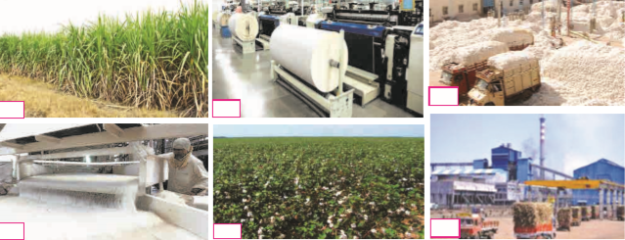

They will be able to answer the following questions:

1. Name the two industries
2. Name the raw material and the finished product of both these industries.
3. How is the raw material converted into the finished product?
4. Why is it necessary to convert the raw material into finished product?

Method: The teacher will then explain:

* how the industries develop and gives a boost to industrialization
* factors affecting the location of an industry
* logic behind development of cotton industry in Maharashtra
* location (suitable) is very important for the development of the industry
* Industries developed in Maharashtra and discuss the reasons behind the same
* Concept of rainshadow, southwesterly winds, monsoon climate, orographic rainfall

**Group Activity:** The students will watch the video and draw the mind map on the paper about the details of industries.

**Types of Industries:** [**https://www.youtube.com/watch?v=d3d2rULZXWQ**](https://www.youtube.com/watch?v=d3d2rULZXWQ)

***Low tech version of Mind Map______*_________________________________**

Drawing mind map with hand on the paper

**Types of Industries**



***High Tech Version of Mind Map_____________________________________***

1. **Mind mapping in Microsoft Word Document (Offline)**

**Steps:**

* Insert shapes in word document and then add arrows wherever needed.
* You can change the colour and effect of the font and box by selecting “Format Text Effects”
* You can add clipart/picture/photo by downloading from the internet or by creating one in the Microsoft MS paint.

**Heavy Industry**

**Small Industry**

**Types of Industries**

**Cement, Sugar, Iron and steel etc.**

**e.g. Making of earthen pots**

**Medium Industry**

**e.g. Fruit processing industries, jaggery making etc.**

**Technology Based activity: Once the students have prepared the mind map, they will be introduced with the Mind mapping tools like ‘One note 2016’ and ‘Popplet’. Then they will be asked to make the same mind map using any one tool by using clipart/ pictures from the internet. The teacher will share the link of popplet which she has made to give them an idea:** [**http://popplet.com/app/#/4937304**](http://popplet.com/app/#/4937304)

**2. Mind mapping in ‘Popplet’ (Online application)**

**Steps:**

* **Type** [**http://www.popplet.com**](http://www.popplet.com) **on the address bar**
* **Sign up by filling in the personal information and login using your username and password**





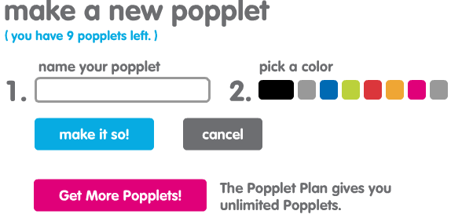

* **Observe public popplet to get an idea of how to make one**
* **Select to make your own popplet**
* **Name your project and choose a colour for your text. Select new popple by clicking on the settings icon and start exploring the different ways to make your mind map interesting and appealing.**

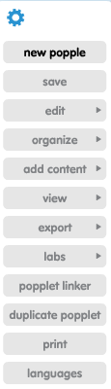

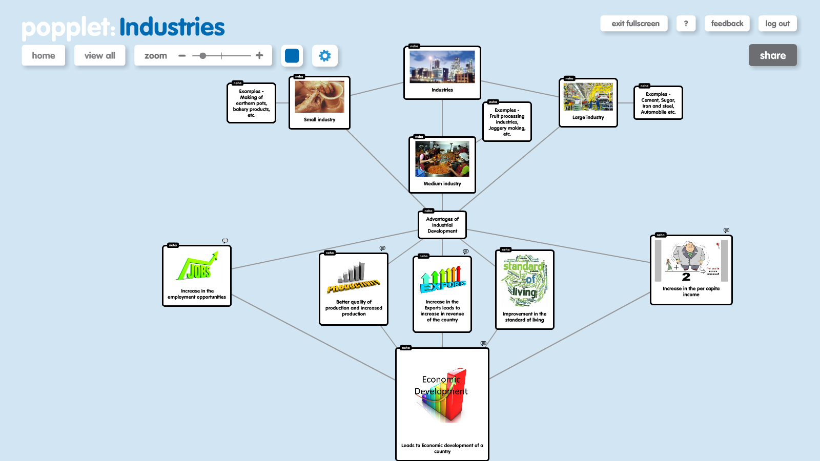

**Once the Popplet is ready, share it with the teacher and other students by selecting ‘share’ option and students will be evaluated on the basis of below rubric:**

Evaluation :Making A Map : Mind Map Rubric

|  |  |  |  |  |
| --- | --- | --- | --- | --- |
| CATEGORY | **4** | **3** | **2** | **1** |
| **Format** | Mind map follows the branch or hook format. | Mind map partially follows the branch or hook format. | Mind map follows another format, such as bubbles, circles, boxes, lines, etc. | Mind map does not consistently follow any format or is chaotic and difficult to understand. |
| **Color** | The mind map is bright, colourful and attractive | The mind map uses few colors and looks ok. | The mind map is using only one color. | The mind map is not colored. |
| **Content** | The mind map includes the MAJOR points of the material. | The mind map misses some major points of the material. | The mind map misses most major points of the material. | The mind map presents no major points. |
| **Use of cliparts/ videos/images** | The mind map radiates from the center of the page. Ideas branch out from other ideas in a logical and organized manner. | The mind map radiates from a central point. Some ideas branch out of other ideas; some branches are a single line extending from the center. | The mind map radiates from a central point. Few ideas branch out of other ideas; most branches are a single line extending from the center. | The mind map radiates from a central point. No ideas branch out of other ideas; all branches are a single line extending from the center. OR: The mind map does not radiate from a central point. |
| **Neatness** | The mind map is very neat and orderly. The mind map is clearly readable. | The mind map is somewhat neat and orderly. The mind map is clearly readable. | The mind map is not very neat and orderly. The mind map is readable. | The mind map is not readable. (This may affect other portions of the grade). |

The students will observe the map and answer the below questions:

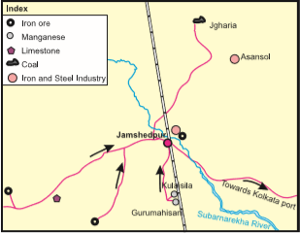

1. For each industry prepare a list of the necessary factors.
2. For each industry give an explanation for the location suggested by you.
3. In a similar manner for which other industries can you decide a suitable location?

**Home Assignment: The students will be asked to explore the internet to find out the information about the industrially developed state in groups. By this they will gain insight about urbanization, availability of natural resources etc.**

***Social Awareness: While it is important to utilize any resource to its optimum use, one has to understand that natural resources are limited and should be used wisely before they get exhausted.***

**Period 2:**

**Explore/ Explain: Comprehension**

**Group Activity:** Once the students have understood the types of industries and factors affecting the location of an industry, they will **demonstrate the understanding by sharing the information in 4 groups**.

Teacher will discuss about:

* different raw material being used in different industries
* classification of industries as per their nature
* which industry is profitable

After understanding the students will answer:

1. Name the industry at Jamshedpur?
2. Which raw material is required for this industry?
3. From which areas is this raw material obtained?
4. Why is coal used in this industry?
5. State with reasons if it would be feasible to set up an iron and steel industry in your district?

**Technology Based activity: The students will find out and explain factors affecting the location of the industry by researching on the internet that why is Jamshedpur called as home of Iron and steel industry.**

[**https://www.youtube.com/watch?v=gqpUXQOzeSY**](https://www.youtube.com/watch?v=gqpUXQOzeSY)

**Individual Activity:** Students will observe the pictures given below and state the suitable locations for these industries.

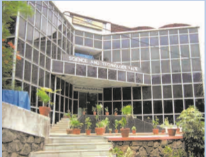 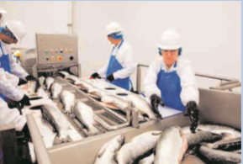 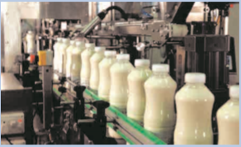

***Low tech Lesson_________________*_________________________________**

**Group activity:** Later students would be divided in the groups to perform the task of preparing questionnaire (MCQ’s) for the different type of industries.

***High Tech Lesson_________________________________________________***

**Technology Based activity: Once the students have prepared the questionnaire, they will be introduced with Kahoot, which a** **Kahoot! is a game-based learning platform, to play, learn, have fun, make a series of multiple choice questions or play new game. The teacher will share the link of MCQ based on Industries which she has made to give them an idea:** [**https://play.kahoot.it/#/k/28a9ff25-0fba-4cdf-a7d1-d8613379147d**](https://play.kahoot.it/#/k/28a9ff25-0fba-4cdf-a7d1-d8613379147d)

**Prepare a “Multiple Choice Questionnaire’ using ‘KAHOOT’ application (Online) using given steps.**

**Steps:**

* **Sign up on the site** [**https://kahoot.com/schools/**](https://kahoot.com/schools/) **and start a free trial**
* **Create Kahoot by writing questions and multiple answers, then select the correct option and decide the time limit and award points. Once questionnaire is prepared, share it with the other users. Game pin is then generated which can be shared with the players.**
* **Ask players to open kahoot.it and insert the game pin. Attempt all the questions and discuss the correct answers with the teachers after the final score.**

Evaluation :

For every student, teacher may give points from 1-4 for each parameter,

|  |  |  |  |
| --- | --- | --- | --- |
| **1** | **2** | **3** | **4** |
| **Poor** | **Average** | **Good** | **Excellent** |

**1. Sequence of the Questions**

**2. Quality of the Questions**

**3. Grades given to each question**

**4. Options given for the Questions**

**5. Questions developing sensitivity**

**6. Time given to solve each question**

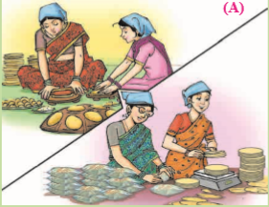 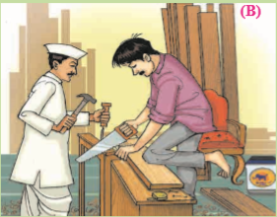 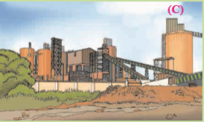

The students will be given set of questions to find out the information by observing the pictures

* Name the industry shown in picture A
* What is the difference between the industries shown in pictures A and B.
* What is distinctive about the industry in picture C.
* Identify the industry shown in the picture above.
* Name some more similar industries.
* Agro based industries

**Group Activity:** The teacher will then conduct a Debate on the topic

**“Industrial Revolution a necessary evil” (Discuss about the advantages and disadvantages of Industrialisation).**

Evaluation for Debate:

|  |  |  |  |  |  |
| --- | --- | --- | --- | --- | --- |
|  | **Superior - 4** | **Proficient - 3** | **Poor - 2** | **Unsatisfactory - 1** | **Score** |
| **Factual Information** | Used many facts to support all arguments. | Used some facts to support all arguments. | Used few facts to support arguments. | Did not present facts to support arguments. |  |
| **Comprehension** | Demonstrated thorough understanding of information. | Demonstrated accurate understanding of important information. | Demonstrated minimal understanding of information. | Demonstrated misunderstanding of the information |  |
| **Persuasiveness** | All arguments were logical and convincing | Most arguments were logical and convincing | Some arguments were logical and convincing | Few arguments were logical and convincing |  |
| **Delivery** | Communicated clearly and confidently; maintained eye contact; excellent voice inflection and delivery rate. | Communicated clearly; frequent eye contact; good voice and delivery rate. | Seldom communicated clearly; poor eye contact; poor voice and delivery rate. | Failed to communicate clearly; no eye contact; monotone delivery. |  |
| **Rebuttal** | Addressed all opponent arguments with counter-evidence. | Addressed most of opponent’s arguments with counter-evidence. | Addressed some of opponent’s arguments with counter-evidence. | Did not address opponent’s arguments. |  |
| **Total Score** |  |  |  |  |  |

Home Assignment:

Students will have to research about the problems created by the Industrialisation.

***Social Awareness: While industries are necessary for the economic development, it is important to control the ‘Pollution’ created by different types of industries.***

**Period 3**

**Apply:** At this level the students will apply the information they have learnt to understand that Industrial Development leads to Economic Development

**Individual Activity:** Study the picture below and classify them as per their advantages and disadvantages in relation to industries.

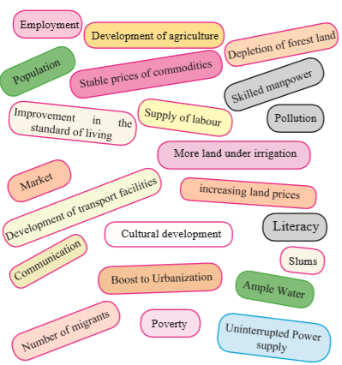

**Technology based activity: After discussing about the above points, students will be sitting in the computer lab in pairs of two for:**

* **Researching about Industrialization and related Environment problems.**
* **Finding information about Maharashtra Industrial Development Corporation (M.I.D.C.) and its role.**

The teacher will then discuss the manmade pollution problems and solutions that can be done at a micro level. Teacher will ask the students about what contributions/changes they have made to reduce the pollution.

**Technology based activity: Then, teacher will talk about Corporate Social Responsibility and discuss the case study of deAsra Foundation (by showing the inspiring video:** [**https://www.youtube.com/watch?v=p84URLXLId4**](https://www.youtube.com/watch?v=p84URLXLId4)**)**

It is non for profit organization helping new and existing business entrepreneurs in India. This initiative taken by founder of Persistent Technologies. The concept of business in a box is innovative concept which allows you to go take business consultation on your own at your own. This will help the students to know about NGO’s

**Group Activity**: Then, the teacher will give the task to the students by forming groups and asking them to become ‘Entrepreneurs’. The students will have to decide their item which they can prepare and sell. By this student will come to know about the concepts such as planning, estimating, investment planning, advertisement, selling of the product, earning profit/ bearing loss.

Evaluation:

**For every student, teacher may give points from 1-4 for each parameter,**

|  |  |  |  |
| --- | --- | --- | --- |
| **1** | **2** | **3** | **4** |
| **Poor** | **Average** | **Good** | **Excellent** |

**1. Business Idea**

**2. Market survey**

**3. Presentation**

**4. Marketing skills**

**5. X factor**

**6. Earnings (Profit, Loss)**

**Technology based activity: Home Assignment: The students will find information using internet about Information Technology Industry.**

***Social Awareness: 1. Though many NGO’s have been formed for helping the needy, we as an individual have to take some steps to contribute for the betterment of our society.***

***2. We have to start thinking about how can we start our own business (Entrepreneurs) so that we can recruit/ provide employment to the others.***

**Period 4**

Teacher will discuss about the information the students have gathered about the blooming IT industry and the respective cities:

**Individual Activity:** Students will answer following questions:

* What are the different ways of obtaining information?
* Which is the fastest way of obtaining information?
* How do WhatsApp, Facebook, Google maps, etc. work?

**Technology based activity:**

**Group activity: Students need to find out the information using internet about make in India and answer the following questions:**

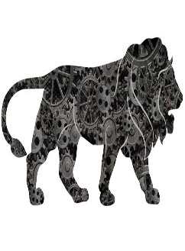

* **In what context is this logo?**
* **What will be the benefit of this programme?**
* **What is the correlation between this programme and employment?**
* **Which are the Navaratana industries of India?**
* **Why do you think they have been accorded this status of Navaratna?**

The teacher will discuss how an individual contribute in economic development of the country. Then teacher will be asking every student to write the below question:

If you become an industrialist, which of the following would you do?

1. l Only make profits
2. l Start a second industry from the earlier one as a supplementary industry.
3. l Will spend some amount for the society after the deduction of tax.
4. l Provide help for the creation of new industrialist.

Evaluation:

Students will be evaluated by answering the following questions created as per the ‘Rubrics’:

**For every student, teacher may give points from 1-4 for each parameter,**

|  |  |  |  |
| --- | --- | --- | --- |
| **1** | **2** | **3** | **4** |
| **Poor** | **Average** | **Good** | **Excellent** |

1. Opinion on the usefulness of Corporate Social Responsibility.
2. Explain how industrial development impacts national development.
3. Prepare a flow chart for the following statements:
4. The journey of clothes we use from the farm to consumer.
5. Essential factors for the location of any one industry
6. Differentiate between:
7. Medium industries – heavy industries
8. Agro based industries – Information Technology industries.

**Technology based activity: The students will be given a project on the topic ‘Water Literacy- The need of the hour’ and introduced to the ‘IEarn’/ similar platform where they can work collaboratively to complete the project. Also, students will prepare a PowerPoint presentation on the same and show it in other underprivileged schools for creating awareness.**

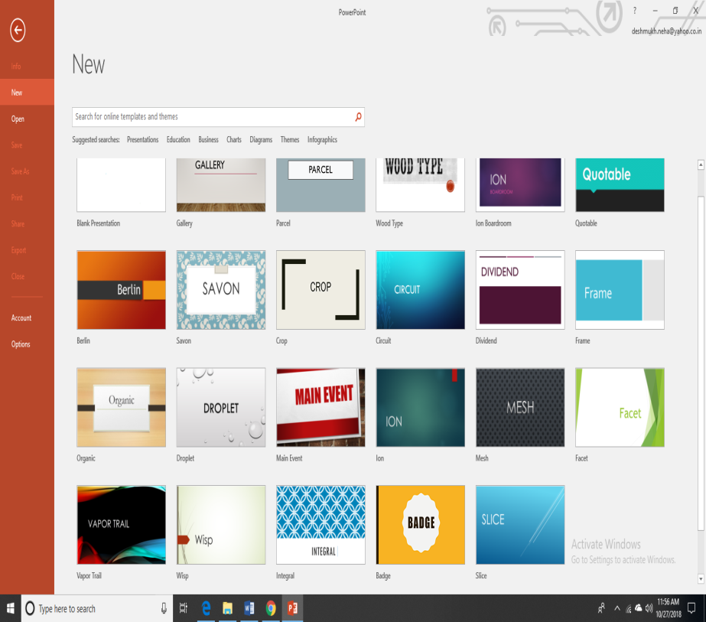

***Social Awareness:***

***1. Though Internet is extremely useful in today’s world, one has to understand the repercussion of misusing it, also with the increasing rates Cyber Crime one has to be careful about declaring the information on social sites.***

***2. Water Literacy, Importance of team work & collaborative approach.***



